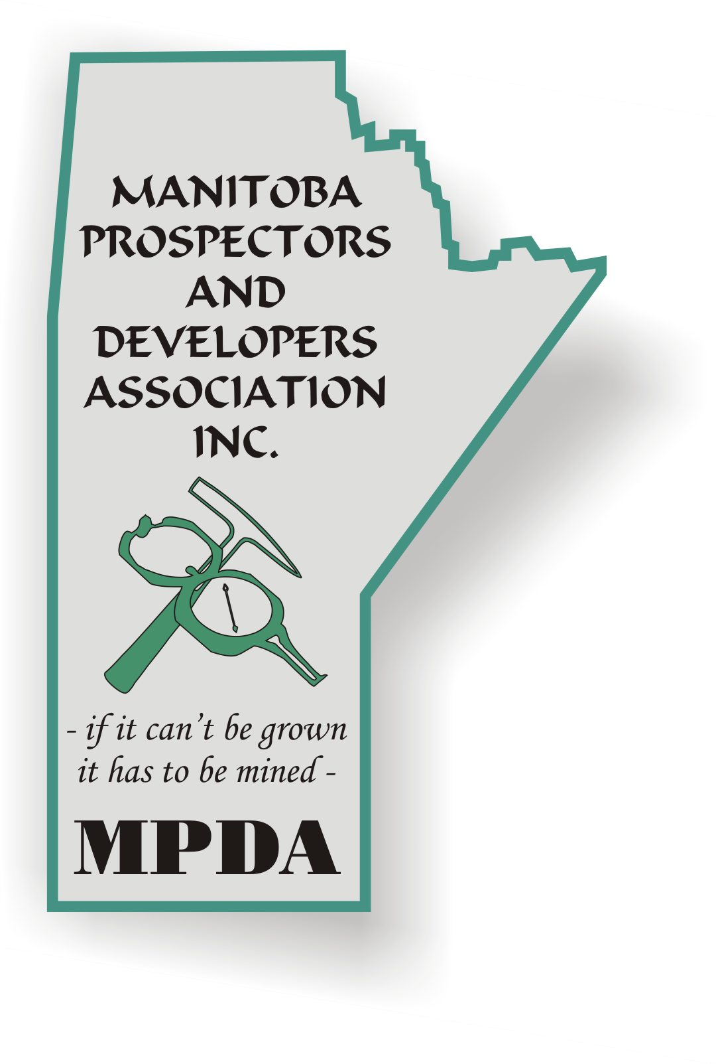
MANITOBA PROSPECTORS
AND
DE DEVELOPERS ASSOCIATION INC.
“- if it can’t be grown it has to be mined – “
Directors/Officers
President: Tom Lewis
Vice-President: Chris Beaumont-Smith
Treasurer: Julia Singh
Secretary: Lori Stewart
Directors: J. C. Campbell, Humid, Jason LaCombe
L,

MPDA Minutes November 6th, / 2019

Meeting held at Canad Inns, Polo Park.
Meeting Chaired by Tom Lewis.
Meeting: 12:05 to 1:10 pm

Welcome: Tom Lewis opened the meeting and gave an overview of the agenda.
Secretary Minutes: Lori Stewart read the minutes from the Sept. 4th meeting – approved.
Treasurer’s Report: Julia Singh gave a Treasurer update.

Business:

- Lori Stewart gave a CCMEC convention update
  - MPDA should have a booth – agreed.
  - Tom Lewis to email sign-up sheet for members to man the booth.
  - Julia Singh to make a poster for the booth.
  - Tom Lewis to provide rock samples for the booth.
  - George Nykuliak suggested a draw for a vest. Ken Klyne to get a donation from IRL.

- CRA and MPDA
  - 2018 made money for MPDA mainly from convention.
  - CRA noticed that there were no tax returns going back several years.
  - Tom Lewis suggested to invest $7,000 to CCMEC 2019.
  - CBS suggest to distribute money to students.
  - George Nykuliak thought of other opportunities like Women In Mining
  - CBS suggested a Prospector of the Year Award.
  - Ultimately it was decided to postpone the decision on funds until after the convention.
  - Andrew Macskimming suggested to ask if CRA contact will reassessment/assessment.
  - Tom Lewis noted there are gaps in the MPDA books, but good back 10 years.
  - George Nykuliak mentioned a plan for after 2019 to become new CCMEC board – not finalized.

- Liaison Committee Update:
  - Met on October 18th at 1pm.
  - Shastri Ramnath’s presentation.
    - Prioritize issues working toward recommendations.
  - Denis Savoie suggested to talk to Dr. Allen Lagimodiere.
    - Working on red tape.
  - Bill Ferreira asked about what issues.
  - Julia Singh did a high level review.
    - ID – PRIORITIZE – RECOMMENDATIONS.
    - 64 issues time vs effort vs ease vs effect.
  - Tom Lewis reviewed issues with the MLCME.
    - Stakes claim (Bill), Pending – Timing.
    - Secure land tenure!
  - Gerry Finkle suggest Agriculture supported by ….

- New Business
  - George Nykuliak and Lyndon from DEL Communications.
    - Mining Review in Print.
    - Will be available for CCMEC.
  - Fraser Institute Survey
    - Contact Ashley.stedman@fraserinstitute.org
  - New Speakers
    - Tom Lewis called for ideas.
    - George Nykuliak suggested CCMEC speakers
    - George Nykuliak suggested University of Manitoba speakers
  - Cliff Duke suggested University College of the North sponsorships for students CCMEC.
  - Canad Inns – Dates for 2020
  - Statures for award – Lottery
Meeting Closed by Tom Lewis at 1:10pm
1st Bill Ferreira
2nd by Denis Savoie
Approved

